Blind spots in the treatment of COVID-19
Hong-bo Gu,Jin-song Zhang

Summary
Medical institutions generally adopt the prone or kneeling positions for assisting patients with severe coronavirus disease 2019 (COVID-19) for airway secretions expectoration. However, a comparison of CT images reveals that this method is not effective. This is because compared to other forms of pneumonia, SARS-CoV-2 leads to a greater extent of destruction to the human bronchial epithelial cells (BECs) in severely ill patients, and leads to a complete loss of mucociliary clearance function.
Given the fact that bronchioles exhibit a variety of different inclination angles in their three-dimensional structure, a slight downward tilt of the chest cavity will not enable effective expectoration simply by means of gravity. In this position, the small inclination angle means that the mucus will flow to other bronchiolar branches before it can be expelled. Hence, most of the mucus will only flow between bronchioles above the tenth order, rather than being expectorated. Therefore, only a very small percentage of the airway secretions will be expelled. In order to achieve effective expectoration by means of gravity, the inclination angle of the chest cavity needs to be increased to 30° or more, or the chest cavity should be completely inverted.
However, a small amount of accumulated mucus in the lungs for a long period may still enables the exponential growth of bacteria and fungi, which will eventually induce an cytokine storm. This is why some patients suddenly experience cytokine storms during their recovery.
This paper proposes an improved method for the efficient induction of expectoration, for effectively disrupting this vicious circle. Due to the low number of COVID-19 patients in China, we are no longer able to attempt this method of treatment, and we hope that medical professionals in other countries will have the opportunity to implement it.

Introduction
Based on available studies, we speculate that a vicious circle exists in the lungs of patients with severe COVID-19. More specifically, after the large-scale destruction of human BECs by SARS-CoV-2, the cilia will not be able to carry out mucus clearance, which will cause mucus build-up in the lungs for a long period. This, together with a total surface area of up to 100 m² in the lungs, will cause bacterial growth in the extensive wounds and mucus fluid. Subsequently, this will lead to inflammation and stimulate the body to produce a more intense immune response, inducing the production of more mucus. If left uninterrupted, this vicious circle will eventually lead to an cytokine storm and death.
The key reference for this study was published by researchers at the UNC Health and UNC School of Medicine, September 3, 2020, Researchers Publish Striking Images of SARS-CoV-2 Infected Cells, which can be accessed via the following link:
https://news.unchealthcare.org/2020/09/unc-researchers-publish-striking-images-of-sars-cov-2-infected-cells/
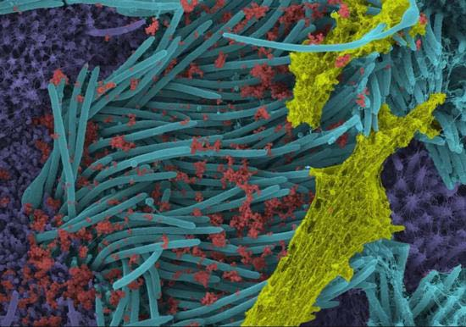
Dr. Camille Ehre's laboratory at the UNC School of Medicine produced high-powered microscopic images showing a significant amount of SARS-CoV-2 viral load on human respiratory surfaces. This is conclusive evidence for the aggressive invasion of human BECs (BECs) by SARS-CoV-2. However, damage to BECs and its derivative diseases have not received the attention they deserve. Based on the extensive destruction of BECs by SARS-CoV-2, we can infer that the following problems will arise:
1. When cilia lose their ability to transport mucus, it creates difficulties in transporting mucus to the throat, which will reduce the viral loads measured by throat swabs. Instead, the mucus will flow in the direction of gravity and accumulate at the base of the lungs. In patients who have been bedridden for a long time, the mucus will accumulate in the posteroinferior part of the lungs.
2. The loss of protection for pulmonary tissues provided by epithelial cells will expose large surface areas to the air. Further, prolonged failure to clean and disinfect the patient's wounds will breed a large number of bacteria and fungi that will further erode deeper tissues. This can lead to extensive inflammation, and possibly even sudden cytokine storms.
3. Inflammation will hinder the regeneration of BECs.
The symptoms speculated above are entirely consistent with the current symptoms of coronavirus disease 2019 (COVID-19).
In fact, there are already certain influenza viruses that can damage BECs and cause bacterial pneumonia. However, most people do not realize that SARS-CoV-2 is much more damaging than previous influenza viruses. Mucus build-up occurs at the base and the posteroinferior part of the lungs in patients with severe COVID-19, and it is less pronounced in bacterial infections secondary to previous influenza viruses. This unique feature suggests that patients with severe COVID-19 sustain devastating damage to BECs, and that their BECs have completely lost their mucociliary clearance function. Further, we can speculate that they experience larger areas and more severe bacterial infections. These consequences of COVID-19, including prolonged mucus accumulation, extensive bacterial infection, and the body’s ensuing immune response, will stimulate each other to produce a vicious circle, and perhaps even an avalanche-like effect, the result of which is an cytokine storm.
In patients with other forms of pneumonia, or in mild cases of COVID-19, the BECs cilia are less severely damaged, and still possess some residual mucus transport function. Hence, when such patients are placed in a general supine position, prone position, or kneeling position, the residual cilia and gravity work together to effectively expel mucus from the lungs, thus circumventing the vicious circle detailed above. However, the BECs cilia of patients with severe COVID-19 are almost completely destroyed, and the aforementioned postures will not aid effective airway secretions expectoration.
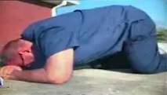
Considering the fact that bronchioles exhibit a variety of different inclination angles in their three-dimensional structure, a slight downward inclination of the chest cavity does not place the majority of bronchioles at an angle suitable for expectoration. In this position, the mucus will flow to other bronchiolar branches before it can be expelled, and hence most of the mucus will only flow between bronchioles above the tenth order, rather than being expectorated. Only patients with excessive mucus build-up in their lungs will produce a very small amount of airway secretions when placed in such a position. Furthermore, the comparison of CT images shows that the expectoration effect of such positions is not significant.
Therefore, it is only by adopting an inclination angle of >30°, or even completely inverting the chest cavity, that mucus can be prevented from flowing between bronchioles with different inclination angles, and be effectively expelled. The diagrams below show the direction of bronchiole mucus flow when standing upright, kneeling, and tilting the chest cavity by more than 30°. We can see that a greater angle of inclination is the key to effective expectoration.

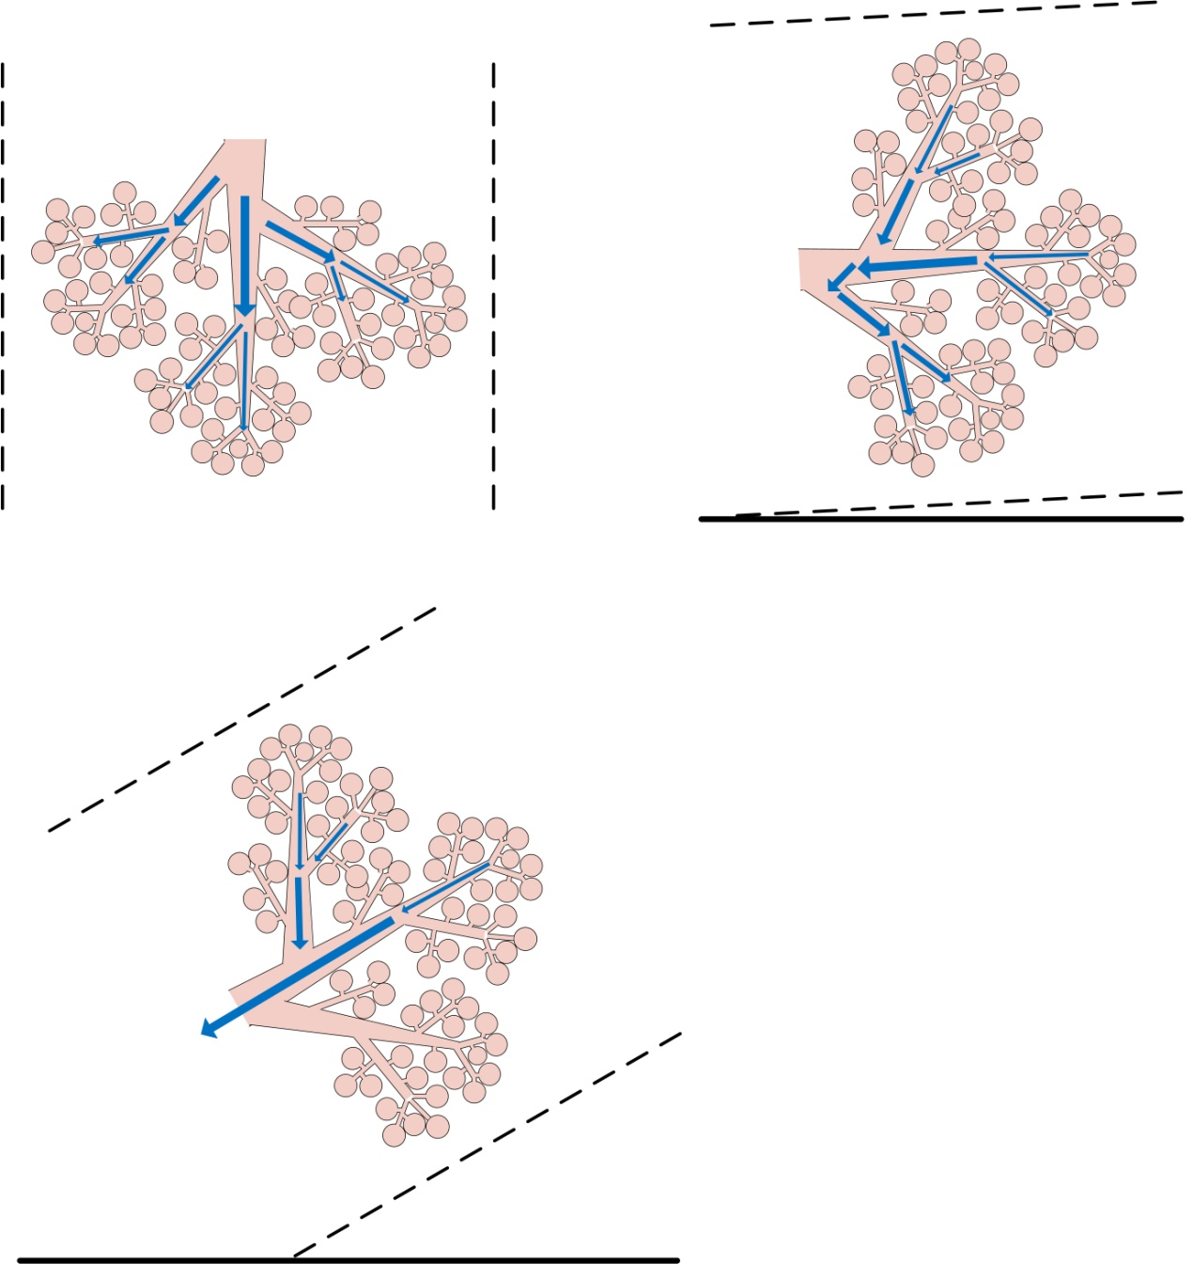

Moreover, the fact that quadrupeds with COVID-19 also have difficulty in expectoration and breathing further demonstrates that the supine or kneeling positions are not effective for airway secretions production. Since both COVID-19 and SARS may have originated from bats, bats roosting upside down might be a possible reason why the viruses did not cause the large-scale extermination of bats. Furthermore, the fact that bats sacrificed their ability to take off while standing upright, and instead evolved this strange roosting position, may have resulted from tens of millions of years of natural selection and elimination, in order to adapt to the damage caused by similar viruses.
Some physicians believe that there is no cause for concern as long as the mucus build-up in the patient's lungs is not sufficient to hinder normal breathing, and this line of thinking may be correct when dealing with other forms of pneumonias in the past. However, this mindset is incorrect for patients with severe COVID-19 because such patients sustain devastating damage to the BECs caused by SARS-CoV-2, and experience a much longer period of mucus build-up. A patient with a burn area of more than 1 m² who is unable to receive proper wound cleaning and anti-inflammatory treatments has a high probability of developing extensive bacterial infection and an cytokine storm. Once the pulmonary BECs are destroyed by SARS-CoV-2, patients with COVID-19 will lose the protective effects of these cells, and hence suffer consequences similar to the loss of the protective effects provided by the skin in burn patients. Moreover, since bronchiolar BECs lose their mucociliary clearance function for expectoration, and artificial interventions for intrapulmonary wound cleaning and anti-inflammatory treatments are difficult to achieve, the patient's lungs are essentially a giant petri dish for bacteria. Further, long-term mucus build-up enables the exponential growth of bacteria and fungi. To make matters worse, the total surface area within the lungs is about 100 m², and such an extensive area of infection will almost inevitably lead to an cytokine storm.
In order to break the vicious circle described above, we recommend that as long as a patient reports that they are unable to achieve spontaneous expectoration, or when mucus build-up is observed in the patient's lungs on CT, regular expectoration with the chest cavity tilted downward at an inclination angle of >30° should be performed regardless of whether the patient is suffering from breathing difficulties. This intervention will produce a similar effect to regular wound cleaning for large burn injuries.

Detailed recommendations
We recommend attempting positional therapy with a downward inclination angle of >30° in the early stages of the disease, with the use of certain assistive measures.

1. Positional therapy with a downward inclination angle.
If special assistive devices are made so that the patient is in a position inclined downward at an angle of >30°, the mucus will flow spontaneously down the patient's throat and be expelled, even without the use of a suction pump. After my own experimentation, this angle produces a better expectoration effect, and can be maintained for more than 2 minutes. In addition, different posture for expectoration can be chosen according to the position of mucus build-up observed in the CT images. The key is to tilt the chest cavity downward and maintain an angle > 30° with respect to the horizontal plane. In addition, to prevent the occurrence of cerebral hyperemia, patients should be returned to a supine or prone position after 1–3 min of expectoration depending on their condition, and several positions can be used alternately.
A dedicated treatment bed could be produced as shown below, or other equipment can be used. If there are no readily available assistive devices, consider using the fitness equipment shown below.
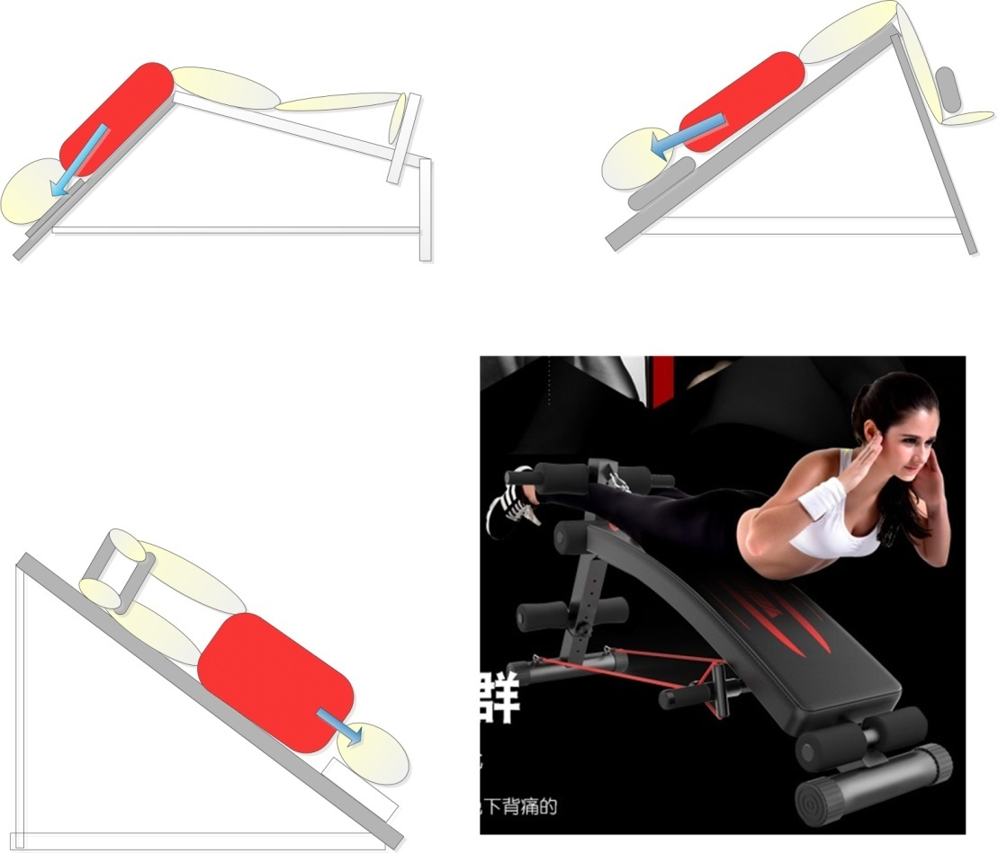
However, if the use of efficient mucolytics and the assistance of vibrations allow airway secretions to be expelled in less than 30 seconds, then the vertically inverted position of the chest cavity may also be considered for expectoration. Naturally, we cannot rule out the fact that individuals in better physical condition are able to persist in this position for longer (e.g. air force pilots who have been specially trained can persist in this position for more than 3 minutes), and so the author highly recommends identifying such cases to test the expectoration effects with different inclination angles and assistive medications, and to analyze the time required.
The above positions for expectoration are based on the first aid positions the author learned as a lifeguard, which are used to rescue a drowning person and remove water from their lungs. These positions are effective for wilderness first aid, but not comfortable enough for a patient who needs to undergo expectoration for a sustained period of time, and so the above improvements were made. The specific first aid positions are shown in the figure below.
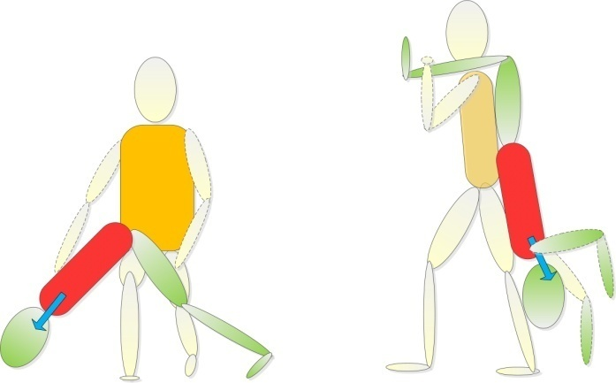
The operating requirement of lifeguards is to tilt the thoracic cavity of the drowning person downward and maintain an angle > 30°, otherwise it will be difficult to effectively drain the water in the lungs. It can be inferred from this that expelling the airway secretions from the patient’s lungs requires a larger tilt angle and a longer time.
How can we tell if this treatment is effective? Healthy individuals have to expectorate （or swallow into the stomach）multiple times a day. However, some patients with COVID-19 cease to expectorate by the mid stage of the disease, and are the most susceptible to the development of severe disease. Thus, the treatment is considered effective if the patient begins expectorating after adopting this method. Furthermore, the effect can be verified after multiple expectorations using CT images.

2. Combination with available mucolytics
The mucus of patients with COVID-19 is viscous and does not have the same fluid properties as the water that accumulates in the lungs of a drowning person. Hence, rapid expectoration may not be achieved by improved positional therapy alone. Therefore, the author recommends using a variety of certified mucolytics to assist this procedure. The research group headed by Jacobson found that hyaluronic acid is overexpressed in severe COVID-19, and is most likely responsible for the production of jelly-like airway secretions. Thus, we can consider using hyaluronidase, which is a certified drug that is commonly used in cosmetic surgery.
https://www.ncbi.nlm.nih.gov/pmc/articles/PMC7410499/
There are a number of existing certified medications that have the ability to thin viscous phlegm that can be used, including acetylcysteine, chymotrypsin, bromhexine, ambroxol, carbocisteine, erdosteine, and fudosteine. In addition, the forensic scientist Liu Liang found during autopsies that this viscous airway secretions immediately dissolved upon contact with alcohol. This is consistent with Jacobson's theory of a jelly-like mucus plug composed of hyaluronic acid hydrogel since the latter can be easily dissolved by alcohol. Therefore, patients can also try inhaling nebulized alcohol, but care must be given to the level of pain perceived by the patient as the application of alcohol can be painful to an epidermal injury, and may lead to similar results in this case.
Some studies have reported the application of the drugs listed above, but not in conjunction with the use of correct expectoration positions. Without the ciliary action of the lungs, the normal sitting and supine positions will have the opposite effect. Thus, even if the viscosity of the mucus is reduced, it will remain in the lungs without being expelled, and may even follow the direction of gravity and flow deeper down the lung. This may be because these studies overlooked the possibility of severe damage to the pulmonary cilia, resulting in a complete loss of function. Instead, they believed that once the mucus has been thinned, the body would be able to expel it spontaneously in the normal prone or kneeling position, which has been sufficient for other forms of pneumonia with less severe damage to the pulmonary cilia. However, this is not the case for patients with severe COVID-19, which is why it is important for mucolytics to be combined with proper expectoration positions.
Common methods of medical treatment, such as oral administration, injection, or inhalation of nebulized solutions, can all be considered for the application of mucolytics.
In addition, given the possibility of inflammation caused by the destruction of pulmonary BECs by SARS-CoV-2, the inhalation of nebulized broad-spectrum antibiotics and alcohol into the lungs should also be considered for the elimination of secondary inflammation.

3. Perform expectoration procedures in the early stages the disease.
During my discussions with medical staff about this treatment method, they were always more concerned about severely ill patients. However, I believe that the expectoration treatment should be initiated even in mild cases. This is because mildly ill patients can position themselves, whereas once they develop severe illness, they may be physically too weak or even semi-conscious, and will require the assistance of 2–3 medical staff for maintaining the required position over a long period of time. The challenge is even greater for patients on ventilator support. Hence, the delay will increase the medical costs.
Therefore, the author suggests that treatment with mucolytics and expectoration at a downward incline should begin as soon as the patient begins to show mild symptoms of mucus build-up, or even when they are asymptomatic, but have stopped normal expectoration, and while the patient is still capable of basic self-care. This will greatly reduce the number and probability of conversion from mild to serious illness, and also reduce the workload of medical staff.
At present, physicians tend to wait until the patient experiences difficulties in breathing before attempting induced expectoration, and this approach is incorrect. This is because patients have different physical constitutions, and some may have less severe mucus build-up, however, a small amount of accumulated mucus in the lungs for a long period may still lead to extensive bacterial and fungal growth, which will eventually induce an cytokine storm. Therefore, regular induction of expectoration is necessary depending on whether the patient can cough up airway secretions spontaneously and the duration of their disease. Induced expectoration should be performed in all patients who have been ill for longer than a given period and are unable to achieve spontaneous expectoration. This will prevent long-term mucus build-up in the patient's lungs and the extensive growth of bacteria and fungi.
According to available case statistics, a higher number of patients were noted who were admitted to ICU and subsequently recovered and had more severe sequelae than patients who were asymptomatic or mildly ill. This is especially the case for pulmonary fibrosis, an irreversible condition, which does not have a specific drug regimen. This point suggests to us that intercepting the disease at the mild stage will not only reduce the mortality rate, but also the distress caused by sequelae.

